**Restaurant Invoice System**

In this project I aim to create a restaurant invoice system whose provide by the restaurant to the customer.

**System Requirements:**

* Python 3.7 download from <https://www.python.org/downloads/>
* Tkinter library for GUI download steps:
  + Open cmd
  + Write command pip install tkinter
* Mysql
  + Write command on cmd pip install mysql

**How to run:**

1. Open cmd on location where you are save/download project and write the command python login_page.py ->press enter like:

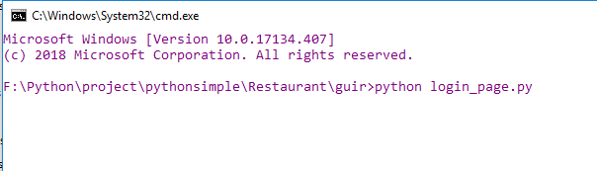

1. After some time the following window is appear:

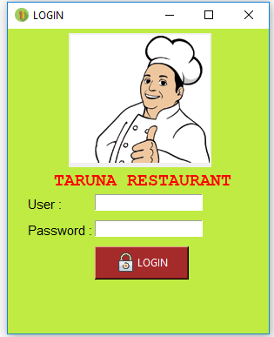

1. Enter user root and password is root which you are enter unter the db restaurant and in the mysql table like login:

1.Firstly you are create a database in mysql name restaurant and create a table under the restaurant database name login.

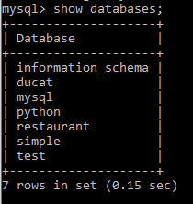

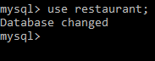

2.Enter the user whose want to login in yours software like following users:

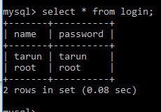

3.Login by the given mysql login table users:

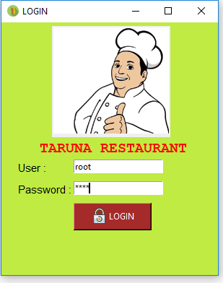

1. After login the add the customer details like **customer number, name, address, mobile** **number ,allocated table(like following):**

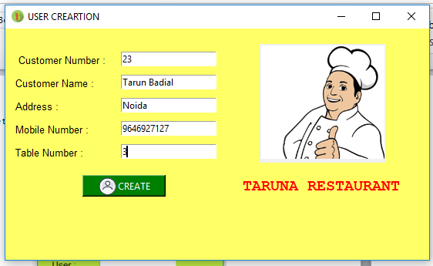

1. Select the items under the course whose want to customer :

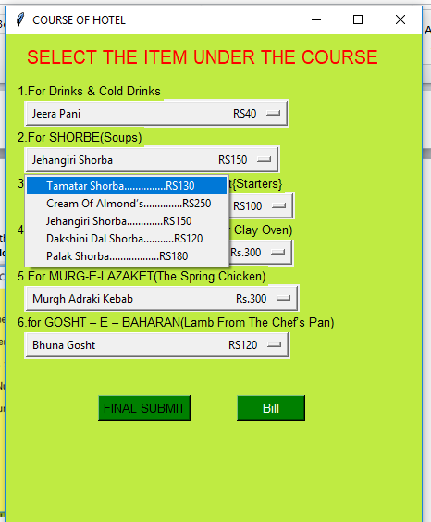

1. After selection the dishes click on the final button and the click on the bill button:

